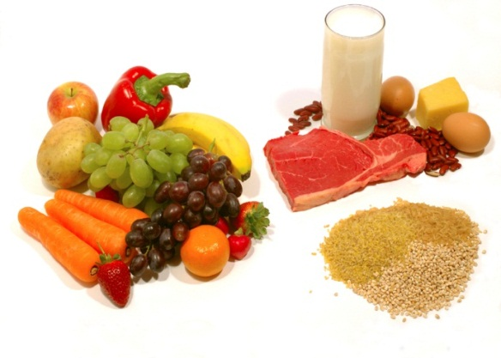 Daycare Menu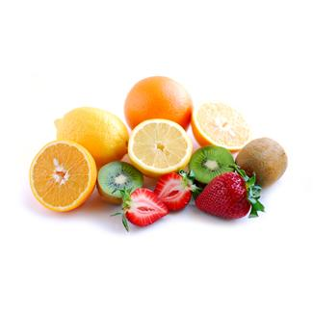
Week I | Monday | Tuesday | Wednesday | Thursday | Friday
 | Cereal ‘n fresh milk | Chicken porridge | Cereal ‘n fresh milk | Havermouth w/ milk | Cereal
 | Rice + chicken nugget + tofu veggie soup | Fried rice + fish nugget | Rice + meat macaroni veggie soup | Spagetti bolognaise | Nasi uduk + fried chicken + tempe
 | Fruit pudding | Fresh fruit | Fruit pudding | Fresh fruit | Fruit pudding
 | Bakpao | Cake/Biscuit | Bakpao | Cake/Biscuit | Bakpao
Week 2 | Monday | Tuesday | Wednesday | Thursday | Friday
 | Cereal | Chicken porridge | Cereal | Chicken porridge | Cereal
 | Rice + chicken sweet stew w/ potato | Rice + telur puyuh + veggie soup | Rice + chicken macaroni vegie soup | Rice + fish nugget + vegie soup | Fried noodle + roasted chicken
 | Fruit pudding | Fresh fruit | Fruit pudding | Fresh fruit | Fruit pudding
 | Bakpao | Cake/Biscuit | Bakpao | Cake/Biscuit | Bakpao

Our food are homemade and cooked using healthy & safe ingredients for children (no MSG)

